SANFL Coach Development Observation Template – Game Day Coaching
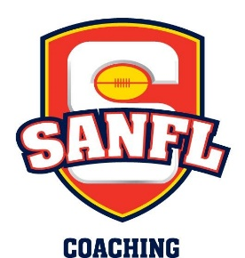

Name of Coach:
Age of team coaching/Club coaching:
Years as a coach:
Coach Developer:

Coach ‘addressing the team’ stats sheet (provide a dash in the appropriate box every time you see the relevant behavior)

Coaching during breaks/addresses | Positive statement made | Neutral statement made | Negative statement made | Questions asked to players | Number of key points | Length of total time talking
Pre-Game

Q1

Q2

Q3

Post-Game

Coaching during the game stats sheet (provide a dash in the appropriate box every time you see the relevant behavior)

Coaching during the game | Positive statement made | Negative statement made | Barracking or commentating | Questions asked to assistant coaches | Instruction given to player or through runner
Q1

Q2

Q3

Q4

*The Coach and Coach Developer to reflect together of the results of the above 2 stats sheets
*The below section is then to be completed in collaboration with Coach and Coach Developer

Things currently doing well | Area(s) to develop | How are you going to achieve this?

