Age Group | Number of Umpires  Appointed | Fee per umpire
SANFL Juniors
MIXED Non-Premiership
Under 7 | 1 | $40
Under 8 | 1 | $45
Under 9 | 1 | $50
Under 10 | 1 | $50
Under 11 | 2 | $50
BOYS Premiership
Under 12 | 2 | $63
Under 13 | 2 | $68
Under 14 | 2 | $80
Under 15 | 2 | $84
Under 16 | 2 | $95
Under 17.5 Div 2-4 | 2 | $116
Under 17.5 Div 1 | 3 | $105
GIRLS
Under 8 | 1 | $45
Under 10 | 1 | $50
Under 12 | 2 | $63
Under 14 | 2 | $80
Under 16 | 2 | $95
Under 18 Div 2-4 | 2 | $116
Under 18 Div 1 | 3 | $105
Boundary Umpires | Per appointment | $68
Goal Umpires | Per appointment | $52

FIELD UMPIRES
- As per SANFL Juniors By-Law - Rule 7.1.2.2, in matches where two field umpires are allocated and only one is available, the field umpire who officiates will receive a 1.5 match payment.

Age Group | No of Umpires  Appointed | Fee per umpire
SANFL Schools
Year 2 | 1 | $45
Year 3/4 | 1 | $50
Year 5/6 | 1 | $55
IGSSA
Middle A/B/C | 2 | $80
Senior A/B/C | 2 | $95
Please note: IGSSA and School knockout fees may vary depending on match conditions, quarter length and age group.

No of Umpires | Fee per umpire
2024 AFL Half time (Auskick)
6 (1 per oval)  Aus kick match (6v6) or a little league match - U12s (10 v 10). | Complimentary tickets to the AFL match

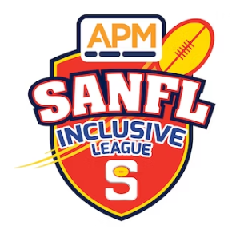

Competition |  | Number of umpires appointed |  | Fee per umpire
SANFL Inclusive League

Inclusive league |  | 2 |  | $85
Inclusive league |  | 2 |  | $45
SANFL Wheelchair Football
Competition | Number of umpires |  | Field Fee |  | Goal Fee
League | 2 Field/goal |  | $75 |  | $30
Reserves | 2 Field/goal |  | $50 |  | $30

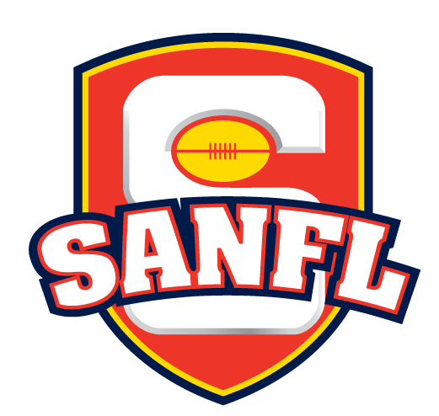

Competition | Field Umpires | Boundary Umpires | Goal umpires (2)
Youth Development squads (Girls)

Under 15 | $80 | $50 | $50
Under 17 | $95 | $50 | $50
Youth Development squads (Boys)

Under 13 | $68 | $50 | $50
Under 15 | $84 | $50 | $50

