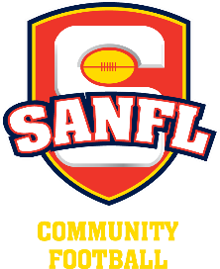
COUNCIL LIAISON OFFICER

Reports to: Committee

Purpose of the role

The Council Liaison Officer will form strong relationships with key local council staff (i.e. Sport and Recreation Staff, Council CEO, Councillors and the Mayor)

Qualifications & Desirable Characteristics
- Organisational skills
- High communication skills
- Comfortable a building relationship with Council
- Approachable and able to represent the club in council activities and public forums

Duties and Responsibilities
Prior, during and post season the Council Liaison Officer duties may include but are not limited to:

- Ensure the club has all required council permits.
- Undertake a safety review of the council facilities that are handed over to the club for the season.
- Create and maintain a register of keys that are distributed for sporting facilities and make a note of who has them.
- Research Council events for the year and identify if the club can participate in the event to promote themselves and support the council’s initiatives (e.g. ANZAC Day parades, Australia Day events, Easter parades and more community events)
- Make sure you are the first point of contact between Council and the club.
- Distribute all messages from Council to the appropriate people within the club.
- Post-season, collect all keys that have been distributed out and return to the Council whilst updating the register.
- Ensure all facilities are clean and vacated by the date required by the Council.
- At the end of the year review and update your position description to ensure it continues to reflect the requirements of the role.

Time Commitment: 5-10 Hours per week or as requested.

