**TENDER AUCTION**

All bids must be above the reserve stated and each bid must increase by a minimum of $5.00. A five (5) minute warning will be issued before the closure of the Tender Auction. No bids will be considered after the closure has been announced. All successful bids must be paid by 10.30 pm on the night unless otherwise negotiated.

LOT 1

**# 51 # 27**

**MAX LITSTER JACK WHEARE**

 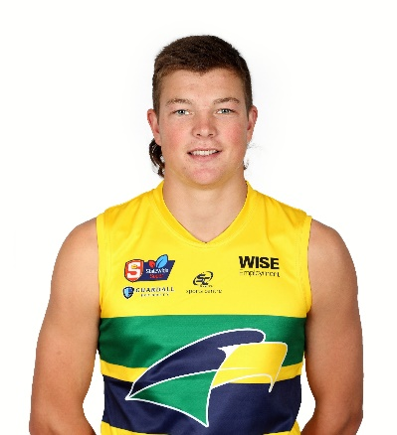

|  |  |
| --- | --- |
| **NAME & PHONE NO** | **BID** |
|  |  |
|  |  |
|  |  |
|  |  |
|  |  |
|  |  |
|  |  |
|  |  |
|  |  |
|  |  |
|  |  |
|  |  |
|  |  |
|  |  |
|  |  |
|  |  |
|  |  |
|  |  |
|  |  |
|  |  |
|  |  |
|  |  |
|  |  |

**TENDER AUCTION**

All bids must be above the reserve stated and each bid must increase by a minimum of $5.00. A five (5) minute warning will be issued before the closure of the Tender Auction. No bids will be considered after the closure has been announced. All successful bids must be paid by 10.30pm on the night unless otherwise negotiated.

LOT 2

**# 14 # 47**

**LACHLAN HOILE CORMACK O’RILEY**

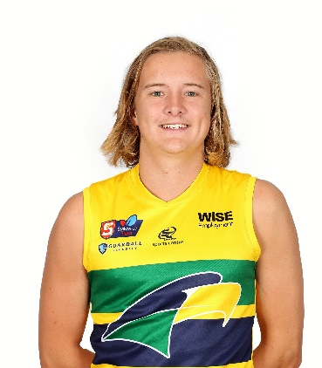



|  |  |
| --- | --- |
| **NAME & PHONE NO** | **BID** |
|  |  |
|  |  |
|  |  |
|  |  |
|  |  |
|  |  |
|  |  |
|  |  |
|  |  |
|  |  |
|  |  |
|  |  |
|  |  |
|  |  |
|  |  |
|  |  |
|  |  |
|  |  |
|  |  |
|  |  |
|  |  |
|  |  |
|  |  |

**TENDER AUCTION**

All bids must be above the reserve stated and each bid must increase by a minimum of $5.00. A five (5) minute warning will be issued before the closure of the Tender Auction. No bids will be considered after the closure has been announced. All successful bids must be paid by 10.30 pm on the night unless otherwise negotiated.

LOT 3

**# 49 # 48**

**ZAC BUCK JAY WATSON**



|  |  |
| --- | --- |
| **NAME & PHONE NO** | **BID** |
|  |  |
|  |  |
|  |  |
|  |  |
|  |  |
|  |  |
|  |  |
|  |  |
|  |  |
|  |  |
|  |  |
|  |  |
|  |  |
|  |  |
|  |  |
|  |  |
|  |  |
|  |  |
|  |  |
|  |  |
|  |  |
|  |  |
|  |  |

**TENDER AUCTION**

All bids must be above the reserve stated and each bid must increase by a minimum of $5.00. A five (5) minute warning will be issued before the closure of the Tender Auction. No bids will be considered after the closure has been announced. All successful bids must be paid by 10.30 pm on the night unless otherwise negotiated.

LOT 4

**# 26 # 50**

**MITCH MEAD TYRAN HILL**



|  |  |
| --- | --- |
| **NAME & PHONE NO** | **BID** |
|  |  |
|  |  |
|  |  |
|  |  |
|  |  |
|  |  |
|  |  |
|  |  |
|  |  |
|  |  |
|  |  |
|  |  |
|  |  |
|  |  |
|  |  |
|  |  |
|  |  |
|  |  |
|  |  |
|  |  |
|  |  |
|  |  |
|  |  |

**TENDER AUCTION**

All bids must be above the reserve stated and each bid must increase by a minimum of $5.00. A five (5) minute warning will be issued before the closure of the Tender Auction. No bids will be considered after the closure has been announced. All successful bids must be paid by 10.30 pm on the night unless otherwise negotiated.

LOT 5

**# 8 # 56**

**WILL NEUMANN ZAC PHILLIPS**

 

|  |  |
| --- | --- |
| **NAME & PHONE NO** | **BID** |
|  |  |
|  |  |
|  |  |
|  |  |
|  |  |
|  |  |
|  |  |
|  |  |
|  |  |
|  |  |
|  |  |
|  |  |
|  |  |
|  |  |
|  |  |
|  |  |
|  |  |
|  |  |
|  |  |
|  |  |
|  |  |
|  |  |
|  |  |

**TENDER AUCTION**

All bids must be above the reserve stated and each bid must increase by a minimum of $5.00. A five (5) minute warning will be issued before the closure of the Tender Auction. No bids will be considered after the closure has been announced. All successful bids must be paid by 10.30 pm on the night unless otherwise negotiated.

LOT 6

**# 43 # 53**

**CONNOR MCLEOD LIAM UEDING**

 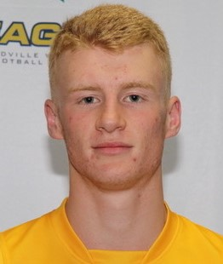

|  |  |
| --- | --- |
| **NAME & PHONE NO** | **BID** |
|  |  |
|  |  |
|  |  |
|  |  |
|  |  |
|  |  |
|  |  |
|  |  |
|  |  |
|  |  |
|  |  |
|  |  |
|  |  |
|  |  |
|  |  |
|  |  |
|  |  |
|  |  |
|  |  |
|  |  |
|  |  |
|  |  |
|  |  |

**TENDER AUCTION**

All bids must be above the reserve stated and each bid must increase by a minimum of $5.00. A five (5) minute warning will be issued before the closure of the Tender Auction. No bids will be considered after the closure has been announced. All successful bids must be paid by 10.30 pm on the night unless otherwise negotiated.

LOT 7

**# 44 # 58**

**BROCK THOMSON CHARLIE BLAIR**

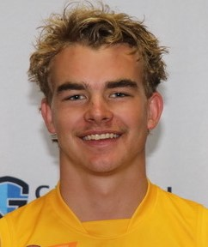 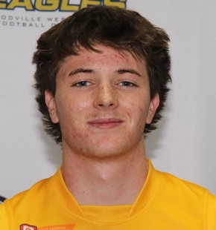

|  |  |
| --- | --- |
| **NAME & PHONE NO** | **BID** |
|  |  |
|  |  |
|  |  |
|  |  |
|  |  |
|  |  |
|  |  |
|  |  |
|  |  |
|  |  |
|  |  |
|  |  |
|  |  |
|  |  |
|  |  |
|  |  |
|  |  |
|  |  |
|  |  |
|  |  |
|  |  |
|  |  |
|  |  |

**TENDER AUCTION**

All bids must be above the reserve stated and each bid must increase by a minimum of $5.00. A five (5) minute warning will be issued before the closure of the Tender Auction. No bids will be considered after the closure has been announced. All successful bids must be paid by 10.30 pm on the night unless otherwise negotiated.

LOT 8

**# 52 # 57**

**SAM NICHOLLS MISHAI WOLLOGORANG**

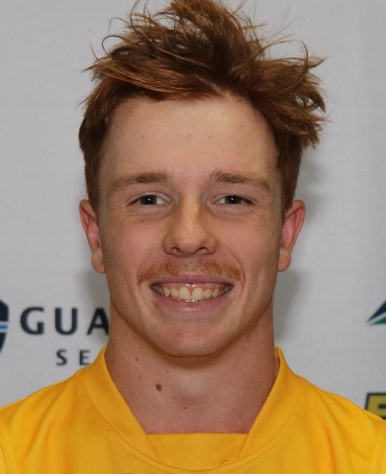 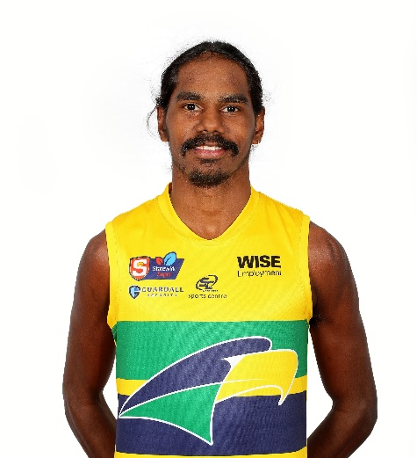

|  |  |
| --- | --- |
| **NAME & PHONE NO** | **BID** |
|  |  |
|  |  |
|  |  |
|  |  |
|  |  |
|  |  |
|  |  |
|  |  |
|  |  |
|  |  |
|  |  |
|  |  |
|  |  |
|  |  |
|  |  |
|  |  |
|  |  |
|  |  |
|  |  |
|  |  |
|  |  |
|  |  |
|  |  |

**TENDER AUCTION**

All bids must be above the reserve stated and each bid must increase by a minimum of $5.00. A five (5) minute warning will be issued before the closure of the Tender Auction. No bids will be considered after the closure has been announced. All successful bids must be paid by 10.30 pm on the night unless otherwise negotiated..

LOT 9

**# 28 # 16**

**ADAM D’ALOIA MATTAES PHILLIPOU**

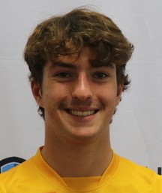 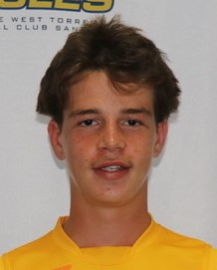

|  |  |
| --- | --- |
| **NAME & PHONE NO** | **BID** |
|  |  |
|  |  |
|  |  |
|  |  |
|  |  |
|  |  |
|  |  |
|  |  |
|  |  |
|  |  |
|  |  |
|  |  |
|  |  |
|  |  |
|  |  |
|  |  |
|  |  |
|  |  |
|  |  |
|  |  |
|  |  |
|  |  |

**TENDER AUCTION**

All bids must be above the reserve stated and each bid must increase by a minimum of $5.00. A five (5) minute warning will be issued before the closure of the Tender Auction. No bids will be considered after the closure has been announced. All successful bids must be paid by 10.30 pm on the night unless otherwise negotiated.

LOT 10

**# 36 #46**

**BRAYDON CALVETT**  **ARON ASFAHA**

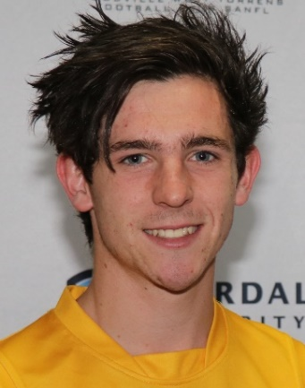 

|  |  |
| --- | --- |
| **NAME & PHONE NO** | **BID** |
|  |  |
|  |  |
|  |  |
|  |  |
|  |  |
|  |  |
|  |  |
|  |  |
|  |  |
|  |  |
|  |  |
|  |  |
|  |  |
|  |  |
|  |  |
|  |  |
|  |  |
|  |  |
|  |  |
|  |  |
|  |  |
|  |  |

**TENDER AUCTION**

All bids must be above the reserve stated and each bid must increase by a minimum of $5.00. A five (5) minute warning will be issued before the closure of the Tender Auction. No bids will be considered after the closure has been announced. All successful bids must be paid by 10.30 pm on the night unless otherwise negotiated.

LOT 11

**# 17 # 59**

**CHARLIE ADAMS OLIVER SINEY**

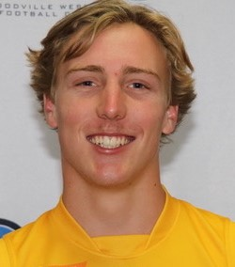 

|  |  |
| --- | --- |
| **NAME & PHONE NO** | **BID** |
|  |  |
|  |  |
|  |  |
|  |  |
|  |  |
|  |  |
|  |  |
|  |  |
|  |  |
|  |  |
|  |  |
|  |  |
|  |  |
|  |  |
|  |  |
|  |  |
|  |  |
|  |  |
|  |  |
|  |  |
|  |  |
|  |  |
|  |  |

**TENDER AUCTION**

All bids must be above the reserve stated and each bid must increase by a minimum of $5.00. A five (5) minute warning will be issued before the closure of the Tender Auction. No bids will be considered after the closure has been announced. All successful bids must be paid by 10.30 pm on the night unless otherwise negotiated.

LOT 12

**# 25 # 34**

**JORDAN LUKAC LUKAS COOKE**

 

|  |  |
| --- | --- |
| **NAME & PHONE NO** | **BID** |
|  |  |
|  |  |
|  |  |
|  |  |
|  |  |
|  |  |
|  |  |
|  |  |
|  |  |
|  |  |
|  |  |
|  |  |
|  |  |
|  |  |
|  |  |
|  |  |
|  |  |
|  |  |
|  |  |
|  |  |
|  |  |
|  |  |
|  |  |

**TENDER AUCTION**

All bids must be above the reserve stated and each bid must increase by a minimum of $5.00. A five (5) minute warning will be issued before the closure of the Tender Auction. No bids will be considered after the closure has been announced. All successful bids must be paid by 10.30 pm on the night unless otherwise negotiated.

LOT 13

**# 32 # 31**

**RYAN BRUCE NATHAN STUDHAM**

 

|  |  |
| --- | --- |
| **NAME & PHONE NO** | **BID** |
|  |  |
|  |  |
|  |  |
|  |  |
|  |  |
|  |  |
|  |  |
|  |  |
|  |  |
|  |  |
|  |  |
|  |  |
|  |  |
|  |  |
|  |  |
|  |  |
|  |  |
|  |  |
|  |  |
|  |  |
|  |  |
|  |  |
|  |  |

**TENDER AUCTION**

All bids must be above the reserve stated and each bid must increase by a minimum of $5.00. A five (5) minute warning will be issued before the closure of the Tender Auction. No bids will be considered after the closure has been announced. All successful bids must be paid by 10.30 pm on the night unless otherwise negotiated.

.

LOT 14

**# 33 # 41**

**DEAKAN JACKSON SAM MICHAEL**

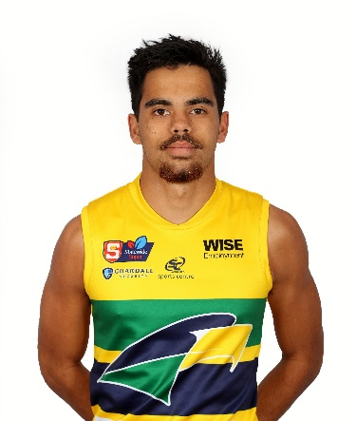 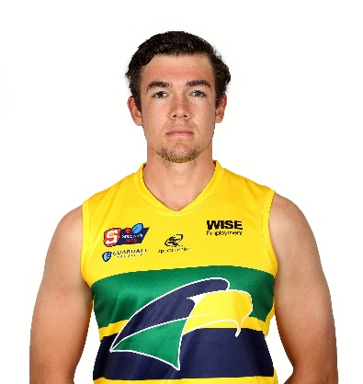

|  |  |
| --- | --- |
| **NAME & PHONE NO** | **BID** |
|  |  |
|  |  |
|  |  |
|  |  |
|  |  |
|  |  |
|  |  |
|  |  |
|  |  |
|  |  |
|  |  |
|  |  |
|  |  |
|  |  |
|  |  |
|  |  |
|  |  |
|  |  |
|  |  |
|  |  |
|  |  |
|  |  |
|  |  |

**TENDER AUCTION**

All bids must be above the reserve stated and each bid must increase by a minimum of $5.00. A five (5) minute warning will be issued before the closure of the Tender Auction. No bids will be considered after the closure has been announced. All successful bids must be paid by 10.30 pm on the night unless otherwise negotiated.

LOT 15

**# 38 # 40 # 45**

**HARRISON DAWKINS DALE PEARCE RYAN WILLIAMS**

  

|  |  |
| --- | --- |
| **NAME & PHONE NO** | **BID** |
|  |  |
|  |  |
|  |  |
|  |  |
|  |  |
|  |  |
|  |  |
|  |  |
|  |  |
|  |  |
|  |  |
|  |  |
|  |  |
|  |  |
|  |  |
|  |  |
|  |  |
|  |  |
|  |  |
|  |  |
|  |  |
|  |  |
|  |  |