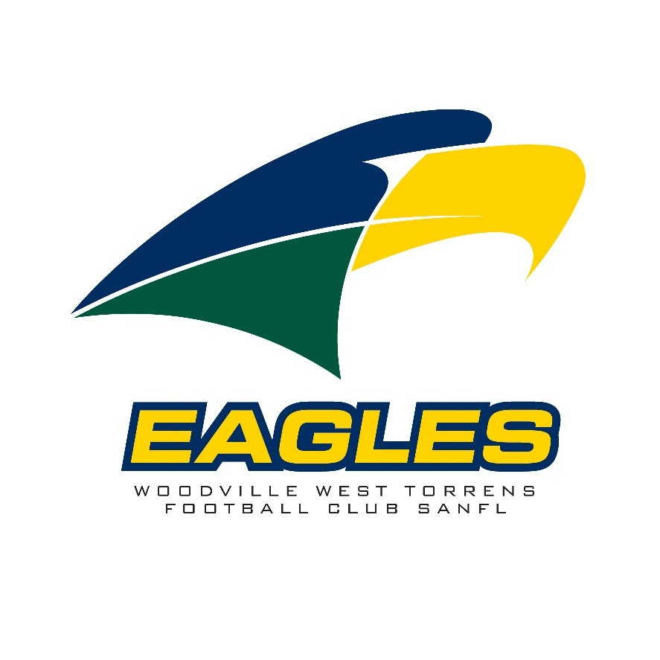 | SANFL - U16’s Male Coach

Woodville West Torrens Football Club (WWTFC)
The Woodville West Torrens Football Club is seeking applications for SANFL U16 Male Head Coach
coaching position for the 2026 season.

The role is vital in developing the next generation of Eagles players and driving our One Club – One Culture philosophy.

About the Club
The WWTFC is one of South Australia’s most respected football clubs, formed through the merger of West Torrens and Woodville in 1991. Since then, the Club has won 5 SANFL premierships, with success across both men’s and women’s programs. Off the field, the Eagles are recognised for their strong community values, commitment to player development, and investment in facilities that ensure an outstanding environment for growth.

The SANFL Pathway
The South Australian National Football League (SANFL) is the peak body for football in South Australia and one of the strongest state leagues in the country. It plays a critical role in the talent pathway, bridging community football and the AFL. The program is an essential stepping stone in this pathway, preparing players for u18’s, senior football and for some, the opportunity to progress to the AFL. As a coach in this program, you will be shaping the next generation of footballers at the highest state level outside of the AFL system.

Key Responsibilities
- Lead and manage the SANFL U16 male program in line with the Club’s values and strategic goals.
- Design and implement training programs that emphasise skill development, teamwork, and resilience.
- Collaborate closely with the SANFL U18 Male Head Coach and Talent Manager to ensure game plans, structures, and development pathways align with the respective League programs.
- Mentor and support assistant coaches, support staff, and players.
- Work in partnership with the Football Operations team and Strength & Conditioning staff to deliver a connected high-performance pathway.
- Oversee match-day responsibilities including team selection, rotations, and in-game coaching.
- Foster a strong culture of accountability, professionalism, and inclusiveness.

What We’re Looking For
- Level 2 AFL Coaching Accreditation (preffered).
- Demonstrated coaching experience at junior, SANFL, AFL, or community level.
- Strong leadership, communication, and mentoring skills.
- Commitment to player development and welfare, with an understanding of the pathway from youth to senior football.
- Experience in developing male talent programs.

Why Join the Eagles?
The WWTFC is proud of its history, its community, and its culture of success. This coaching position offer the opportunity to:
- Contribute to a proud SANFL club with a proven track record of developing elite players.
- Shape the future of football in South Australia through direct involvement in SANFL’s talent pathways.
- Work within a professional and supportive environment that values excellence, innovation, and development.
How to Apply
Applications should include a cover letter and a coaching resume outlining experience and suitability for either role.
Please send applications to: Matthew.goldsworthy@wwtfc.com.au
Applications close: Friday, 24th October 2025

Employer | Woodville West Torrens Football Club (WWTFC)
Reports to | Football Operations Manager and Talent Manager
Departments | Football Operations
Location | Based in Woodville, SA – Eagles Club
Position Overview | As a member of the WWTFC, you will report to the CEO when required with main reporting line to Football Operations Manager and Talent Manager. The role requires you to work closely with key staff to ensure game day coaching and development (training) are closely aligned to the U18 and Senior program. The key function to this role is develop and identify players to progress through to the U18 and Senior Program.
Primary Objectives | The Head Coach of the U16 Male program is responsible for Leading and Managing the development of players within the program, which includes:  - Promote the vision, mission and values of the WWTFC  - Work collaboratively with and report to the Football Operations Manager, Talent Manager and CEO when required.  - Compliment the U18 and Senior Program through player development and education. Implement a coaching structure that drives and encourages players within the U16 program to progress through to the U18 and Senior program.  - Implement match-day strategies closely aligned to the U18 and Senior program.  - Provide direction and work closely with assistant coaches on all training and match day requirements  - Provide feedback on game and training performance via Hudl and Champion Data to the playing group  - Provide individual feedback to players and parents (when required)  - Relationship Management across a diverse stakeholder group including players and parents  - Developing a drive to perform with shared values  - Promoting the Club and its Brand  - Represent the WWTFC at key meetings or events within the SANFL Community - these meetings may be scheduled out of normal business hours
Key Duties | Football Operations  The U16 Male Head Coach will be expected to carry out the following functions:  - Work harmoniously and collaboratively with the Talent Manager and U18 Head Coach including liaison and scheduled meetings.  - Liaise with program coaches, assistant coaches, strength & conditioning personnel, medical personnel, players and WWTFC staff.  - Implement the game plan and program structure in line with the U18 and senior program to ensure fluid movement of players within the WWTFC talent pathway  - Develop U16 SANFL players in a fair and equitable manner to ensure development of all players is a primary focus  - Identify U16 players that should be promoted to the U18 squad post the U16 program  - Attend internal and external functions or events and represent WWTFC as required  People Management  - Build genuine relationships with staff and players within the program  - Have appropriate communications with players and parents regarding individual players  - Lead with inclusivity with development of players and coaches being the primary focus  Work Health and Safety  - Ensure all work practices are carried out in a safe manner and comply with the WWTFC Work Health and Safety Manual
Competency Area | - Highly developed communication skills, both written and verbal  - Relationship management and people management skills  - Strong team player with honesty and integrity attributes  - Good planning, organisational and time management skills  - High level of stakeholder management  - Develop relationships with the WWTFC Board, Staff, Coaches, Players, Members, Supporters, Customers, Sponsors, SANFL Marketing department, SANFL club Marketing Managers  - Ability to consult, communicate, manage conflict and balance competing demands of key stakeholders
Qualifications and Experience | - Playing experience (preferred)  - Experience in an elite sports team or talent environment (preferred)  - Minimum Level 2 AFL Coaching Accreditation (preferred)  - Proficient in technology including vision management (Hudl, Champion Data, GPS)  - Demonstrate strong leadership skills and can create a positive and motivating environment where players can grow, develop and perform  - Willingness to uphold the values & behaviours of the WWTFC  - Flexible and responsive to change in direction and priorities, as and when required  - Collaborative and interactive management style with other coaching staff, employees and Board members of the Club  - Sports administration or similar business or legal qualifications highly regarded  - Drivers Licence  - DCSI Working with Children Employment Check
Remuneration | - To be discussed

